USB3.0 SuperSpeed 4-Port Hub
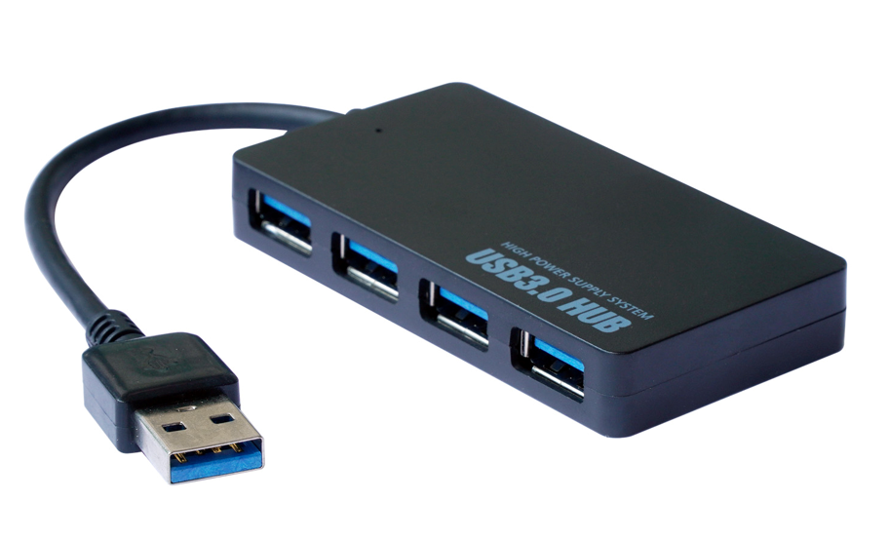

connect multiple USB3.0 devices with ease

Stylish and compact, the superspeed 4-port hub quickly and easily connects your existing USB3.0 storage devices cameras and other digital devices so you can all share your USB3.0 port - in an instant!

Ideal for connecting both SuperSpeed USB3.0 (5Gbps) and your existing USB2.0 (480Mbps) devices into one, convenient Hub. Ideal for when your WindowsTM, MacTM or any other device has only a limited number of SuperSpeed USB3.0 ports.

Connect with ease almost any USB device such as external storage devices, memory card readers, cameras, printers, scanners and a whole host of input devices with total simplicity.

Fully Plug n' Play for all popular operating systems such as WindowsTM, MacTM, LinuxTM and more besides.

SPECIFICATIONS

4-Port SuperSpeed USB3.0 Hub

4x downstream ports, 1-upstream port

5Gbps transfer speeds: Backward 480Mbps compatible

Compliant with USB3.0 and USB2.0

Fully Plug n' Play, no drivers needed

Integral USB surge protection - protects attached USB devices

Integral LED status in a compact, stylish design

WindowsTM 98/2000/XP/Vista, WindowsTM 7 and WindowsTM 8 or WindowsTM 10

MacTM OS X (9.x) or higher, RaspberryTM PI, LinuxTM run-time

Part number: USB3-HB-4PM-V2

Barcode number: 8400800027542

